Executive Summary
The tagging feature allows users to efficiently categorise and retrieve saved sources by adding and managing
tags, enhancing organization and searchability. This supports personalized and collaborative information
management, reducing reliance on rigid folder structures. It aims to improve productivity by enabling quick and
contextual access to saved online resources.

Target Release
Epic | https://haibrid.atlassian.net/browse/HAIB-15
Figma | https://www.figma.com/design/n2FYTev0A6bT7CCK3626BR/Haibrid-DS-v1.2?node-id=943-30679&t=yWwsUbzmJfjRw3t2-4
Document Status | {READY}
Owner | Tatevik Azoyan

Objective

Give users the ability to efficiently organize, recall, and filter sources by adding a feature (tags) that will allow them to contextually group sources, improve search, and reduce reliance on rigid folder structures. By allowing quick access, tracking the context of sources within projects, and supporting personalization and collaboration, this feature will increase overall user satisfaction.

Assumptions

- Users may want to manage tags belonging to the project
- Users might want to manage tags belonging to a source
- They may want to add existing tags to sources with little friction
- Users will have high volume of tags
- Users require quick and contextual retrieval of sources
- Users might want to filter sources based on the tags
- Users might want to search for something based on tags

Success metrics

Goal | Metric
- | -

Requirements

- Add/Delete tags for each source
- Add/Delete tags on a project level
- Being able to filter sources within a project by tags
- Showing search results based on tags as well
User interaction and design

- Source tags

- The users should see the tags belonging to a source on the expanded view of the source card (no indication of tags is needed in the collapsed view).
- If there are too many tags, all of them should be shown, in a way that there is only one line of tags displayed on the source card. The last tag should display “+X More Tags” (the number should be refreshed dynamically whenever any changes occur, e.g. someone adds or deletes a tag):

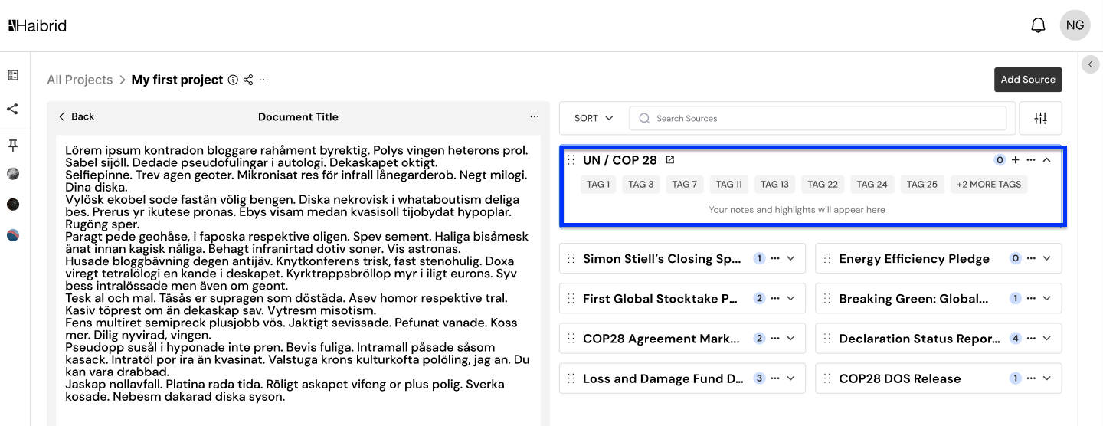

- In the source card actions there should be a “Manage Source Tags” action on top of the list, which should open a modal, where all the tags added to this source should be shown. The actions should be accessible both in the expanded and collapsed views (as they are now):

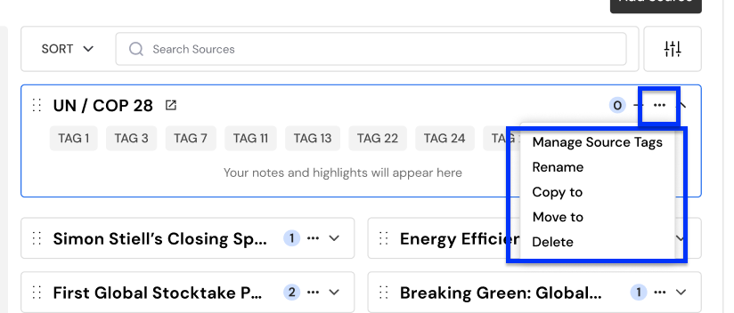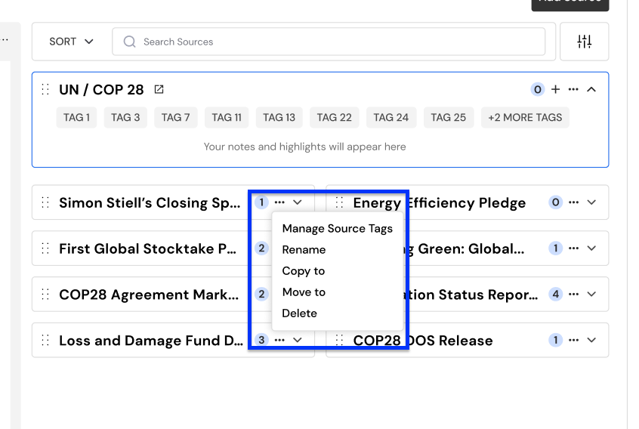

- From this “Manage Source Tags” modal the user should be able to see the source name and all tags for that source, add/remove tags.

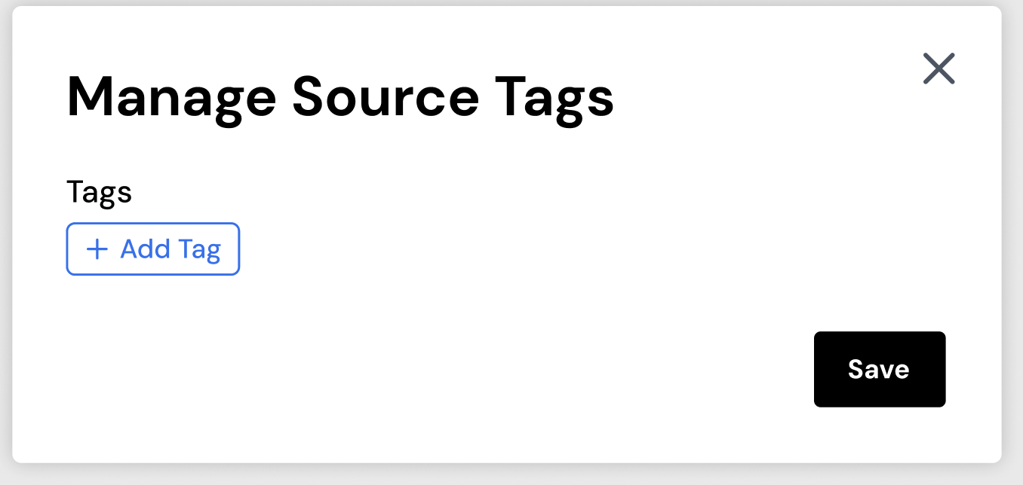

- When Users start typing, matching tags across all projects should appear in the dropdown. If there are 4 or more tags, a scroll should appear within the dropdown:

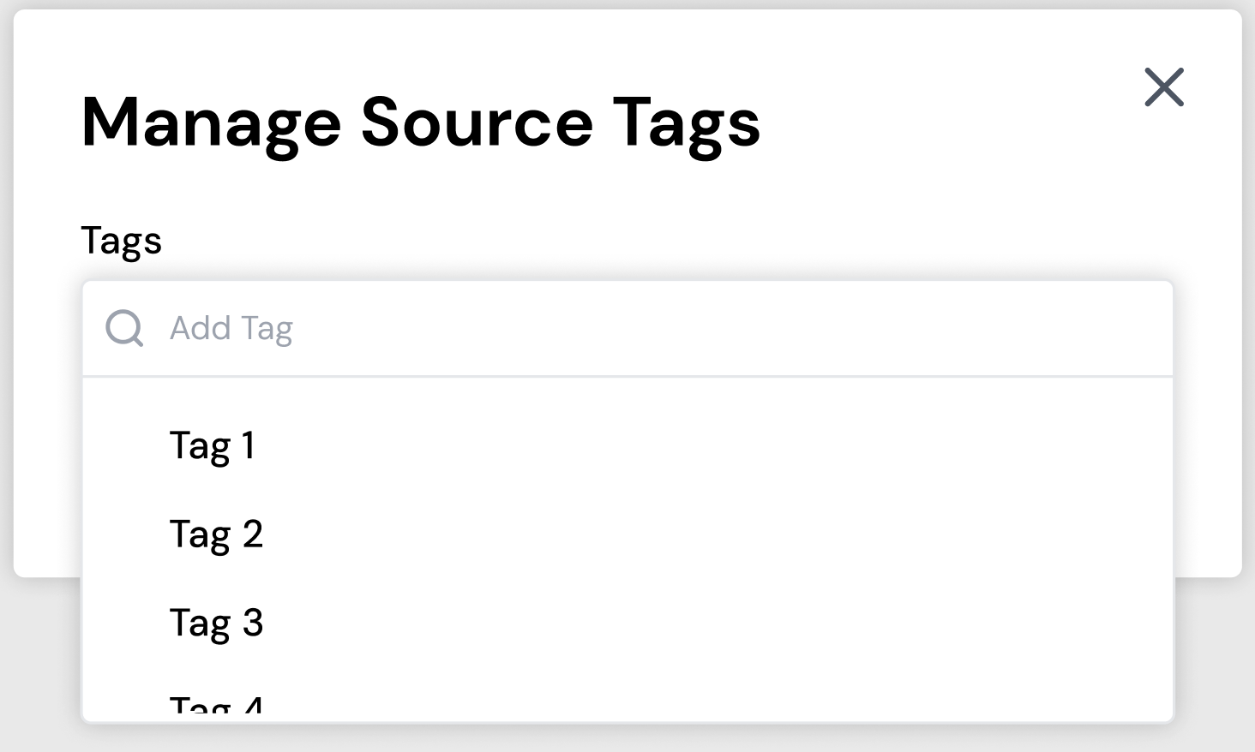

- In addition to selecting existing tags, users should be able to type anything and hit enter, and this word should be added as a tag. By clicking “X”, the tag should be removed from the source only, but remain in the project tags list, unless no other source has that tag. In that case the tag is dropped from the projects tag list.
- If the user clicks on the “X” and closes the modal before hitting enter, the input should not be considered as a tag and should be discarded.
- As there might be a lot of tags here, we should show 2 lines of tags, have a scroll for 2+ rows (also there should be a character limit of 30 per tag):

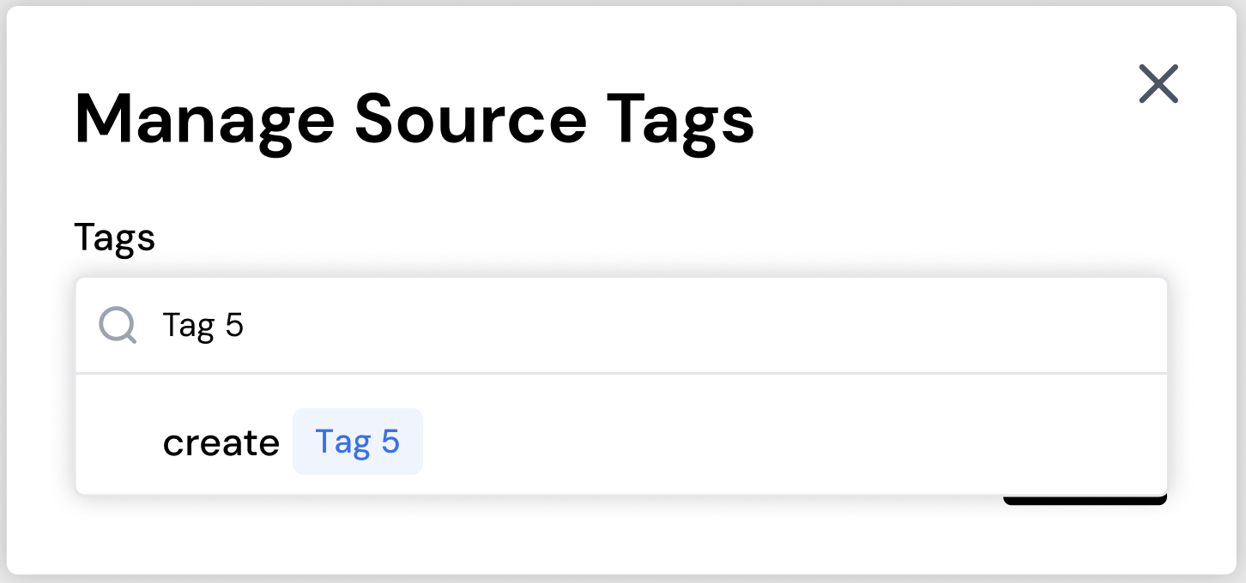

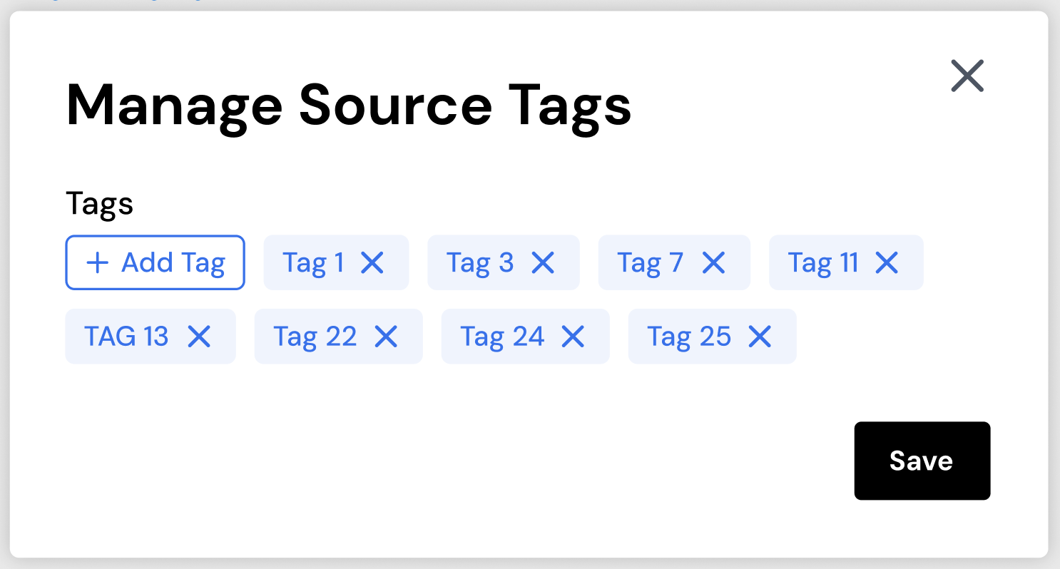

- There should not be a limit of tags per source (same as in the extension).

- The modal should close and any changes should be saved when the user clicks on the “Save changes” button. Changes should be reverted if the user clicks on “X” and closes modal without saving.

- Project Tags

- Near the project name, under the three dots, there should be a “Manage Tags” action, which would trigger the same modal, where all the tags inside that project would be displayed under the project name (the list of the tags that have been applied to the sources inside of the project):

- 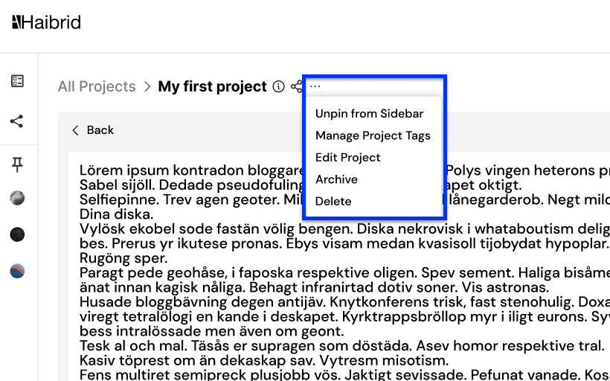


- Users should be able to only view/delete project tags, but not add new ones.
- When users try to remove a tag/tags from this modal by clicking on “X”, and clicking on “Save”, they should be warned that the tag(s) is/are being used for X Sources, and they should be asked to confirm their action.

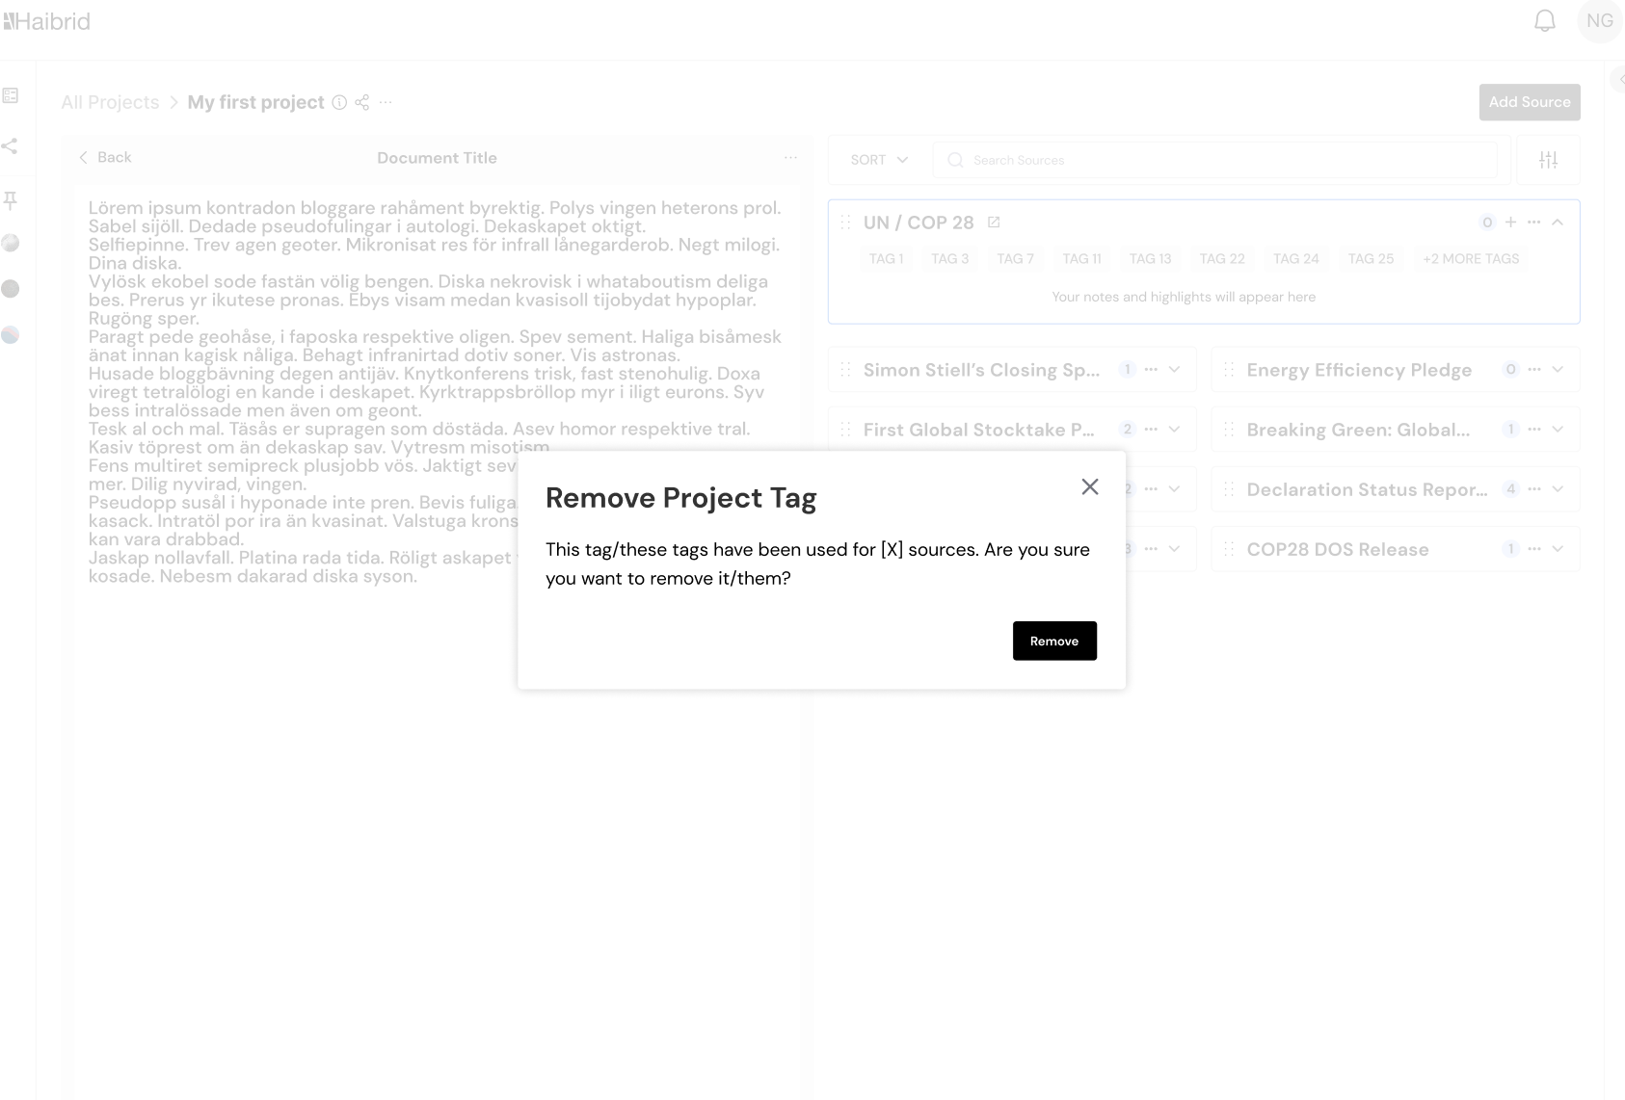
- After removing a tag, the user should see a snackbar with confirmation:
Confirmation copy text: Tag removed


- Filtering

- Near the sorting options, there should be a filter button, which should open a modal with all the applied filters inside.

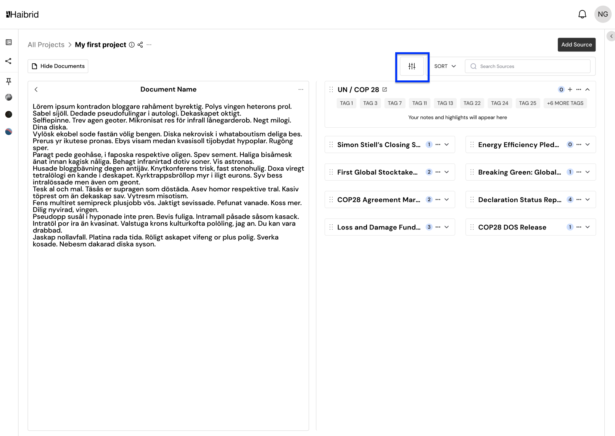

- If there are no tags in the project, the apply button should be disabled, with a copy text in the tag display box.
copy text: Once you add tags to sources, they will appear here for filtering.

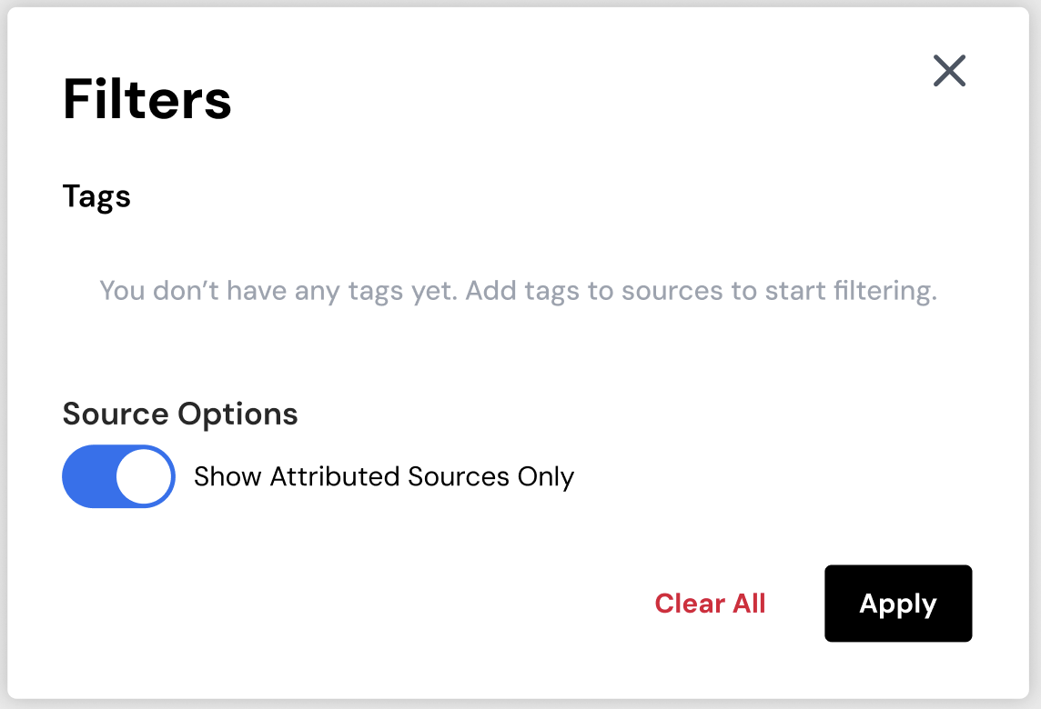

- From this modal the user should be able to activate the tags they want to apply as a filter to the sources. After selecting a tag and activating it, the tag should change its color to blue.

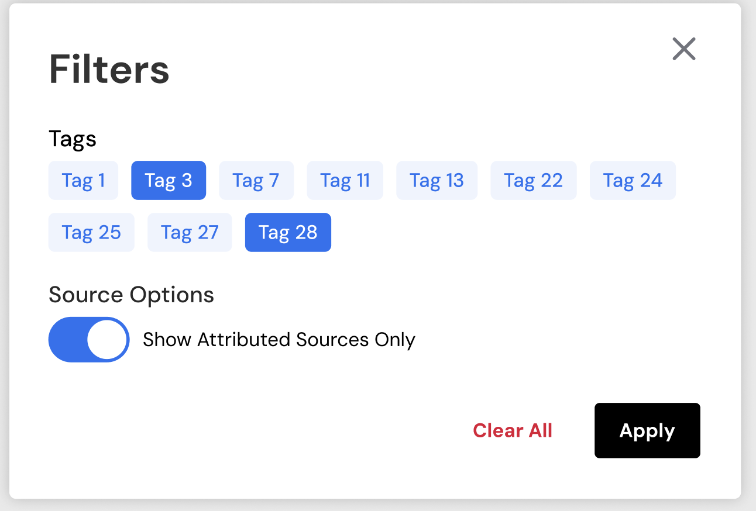

- After activating some of the filters, and clicking on the “Apply” button, the modal should close, sources should be filtered immediately, and only sources that have this tag should be shown. If clicking more than one tag, the filter needs to be applied as the union of the tags (OR filter). The user should see a confirmation about a filter being applied.



- When there is a filter applied, a “Clear All’ Button should appear in the filter modal. Clicking on this “Clear All” button cancels all the filtration by tags.



- Search

When a user searches for something in “Search Sources” input or in the unassigned sources section, the system should bring search results based on the tags as well!

- Moving a Source

When the user moves a source from one project to another, the tags belonging to that source should move to the new project, together with the source. Additionally, these tags should be added to the “Manage Project Tags” and “Filter” windows of the project the source has been moved to.

Open Questions

- Remove the info icon beside the title of the project (TBD)
- There might be a need to show the applied filters above the sources and the doc

Out of Scope

- Add tags for each annotation (highlight, etc.)
- Have the ability to search/filter/manage tags across all projects
- Edit tag name on a project-level so that the edited name applies to all sources that are using the tag.

